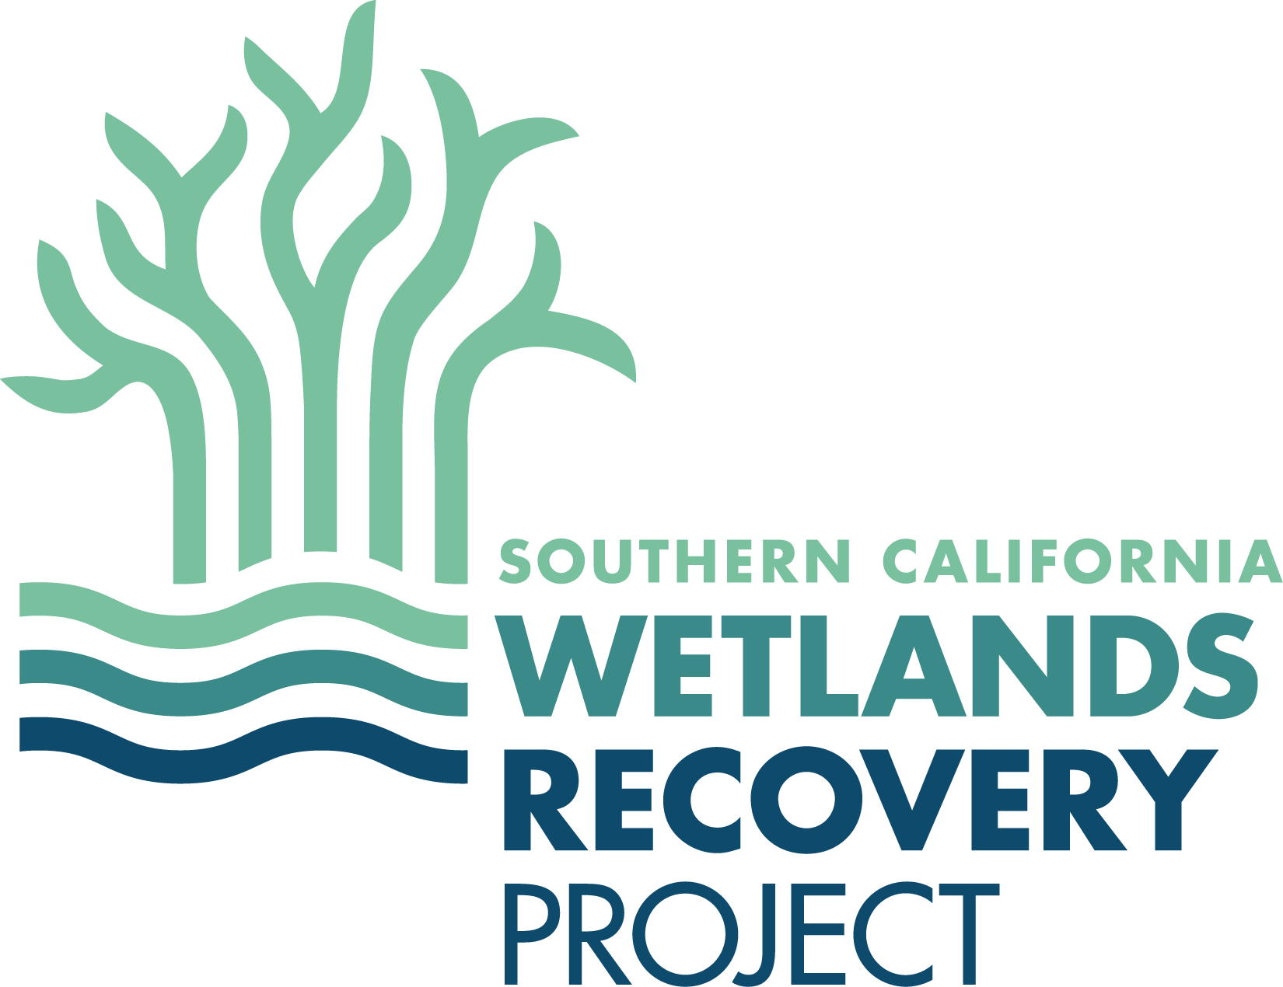

**Southern California Wetlands Recovery Project**

**Directors Group Meeting**

**Agenda**

**October 16, 2024**

**10:00 a.m. – 3:30 p.m.**

**Location:** San Diego Regional Water Quality Control Board, Board Room

2375 Northside Drive, Suite 100

San Diego, CA 92108

**10:00**  **Welcome and Introductions**

Amy Hutzel, Chair, Executive Officer, State Coastal Conservancy

**Recommended Action:**

*Approve Meeting Minutes from October 26, 2023*

**10:10 Work Plan Update**

Katie Nichols, State Coastal Conservancy

* Review high priority wetland restoration and acquisition projects
* San Juan Creek Estuary – 2024 Work Plan Project proposed for addition

*Public comment (each speaker is limited to 2 minutes)*

**Recommended Action:**

*Approve 2024 Work Plan*

**10:25 Regional Monitoring Program Update**

Katie Nichols, State Coastal Conservancy

Dr.Eric Stein, Southern CA Coastal Water Research Project (SCCWRP)

* Review products that have been developed thus far and products that will be developed over the next year

*Public comment (each speaker is limited to 2 minutes)*

**Recommended Action:**

*Endorsement of Sentinel Site Document*

*Commit to reviewing other program products*

**11:05** **Community Wetland Restoration Grant Program**

Kellan Warner, State Coastal Conservancy

* Project overview – review 2024 selected projects

*Public comment (each speaker is limited to 2 minutes)*

**11:15 Wetland Managers Group Work Tasks**

Melissa Scianni, EPA, Chair, WRP Wetland Managers Group

*Public comment (each speaker is limited to 2 minutes)*

**11:30 Update on expansion of WRP to broader Coastal Resilience Efforts**

Megan Cooper, State Coastal Conservancy

*Public comment (each speaker is limited to 2 minutes)*

**11:45 Public Comment on non-agenda items**

*(Each speaker is limited to 2 minutes)*

**12:00 Lunch (on your own)**

**1:30 Site Visit –** Mission Bay: Developing a Wetlands Management an Implementation Plan for [ReWild Mission Bay](https://rewildmissionbay.org/)

Project Proponents, San Diego Bird Alliance

**3:30 Adjourn**