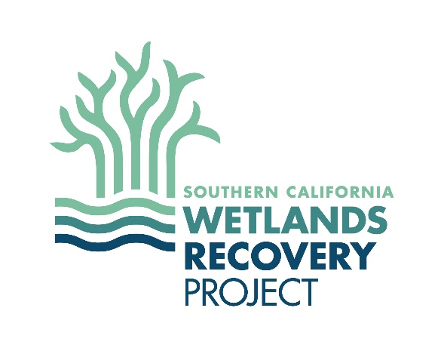

Southern California Multi-Benefit Wetlands Restoration Permitting
“Sand in the Gears”
(adapted from the SF Bay “Sand in the Gears” 2018 report)
August 11, 2022

Following the February 27, 2020 WRP Director’s Group (DiG) meeting the WRP Wetland Managers Group, at the request of the DiG, put together a brief description of some of the common policy conflicts between agencies that have resulted in a slow-down in the permitting process for voluntary (i.e., non-mitigation) restoration projects. This document can be updated as needed as new conflicts are identified.
1. Fill & Type Conversion
Large-scale restoration projects may convert one ‘type’ of aquatic habitat to another ‘type’ (e.g., converting subtidal to intertidal or eel grass habitat). Addition or removal of fill material may be necessary to restore the desired habitat. Type conversion or relocation of regulated aquatic habitat (i.e., waters of the U.S./State, coastal wetlands) can result in a net loss of aquatic habitat, and therefore be interpreted by agency staff as necessitating compensatory mitigation for voluntary restoration efforts.
2. Public Access
Different agencies have different goals pertaining to public access. Some agencies ask project proponents to maximize public access (e.g., including parking lots), while other agencies focus on minimizing it to protect habitat values. Both perspectives have value, but the burden to resolve these conflicts often falls on the applicant to justify their position to each agency and resolve these conflicts in an often long and iterative process. Beyond this, the landowner may be a resource agency charged specifically with protecting particular species and habitats where public access may conflict. The tradeoffs between the value of public access and habitat protection may also have disproportionate impacts on historically excluded communities’ access to the resource and could result in strong public interest and/or legal action regarding these conflicts. Potential resolutions may also be impeded by public concern and lead to permitting delays.

3. Special Status Species and Habitat
In coastal environments, multi-objective projects are often intended to achieve a balance between habitat enhancements for special-status species and general habitat enhancements over a broad area. The presence of special status species or protected habitat at a site will require additional permitting and may affect project design. Legal requirements for “fully protected species” can further affect actions that may be authorized at a site.
4. Invasive Species
Invasive species may provide habitat for native special status species (e.g., eucalyptus providing raptor nesting habitat). Agencies, applicants, and the public may have different perspectives on when and how to remove invasive species when they are providing habitat for native species. Large scale removal of invasive species can also be technically and logistically challenging, as well as expensive.
5. Monitoring
Required monitoring for projects both before and after completion can be expensive. Project proponents are typically unable to sustain significant monitoring programs on their own and developing monitoring requirements the applicant can implement can result in permitting delays. Funding additional monitoring requirements will reduce funding available for restoration actions as part of the project and elsewhere. Monitoring activities require a long-term commitment of resources. Project proponents have difficulty finding funding sources to cover the costs of monitoring. Many funding sources have restrictions on how the money can be used for monitoring, including limitations on the length of the monitoring period.

6. Uncertainty and Risk
Regulatory and funding agencies often want to see certainty in the quantification of project outputs and monitoring results. However, large-scale voluntary restoration projects often have some degree of uncertainty in the timing and degree of outcome (especially in light of sea level rise), as well as uncertainty in project impacts. Requirements for certain outcomes can discourage experimentation, which could help advance the knowledge of the restoration community.
7. Level of Design
Permitting agencies often require a certain level of design to process applications. However, if project proponents spend money on design prior to permitting it is harder to change course in response to agency input. This can create conflicts between permitting agency needs and project proponent needs.

8. Overlapping Authorities
There are many state and federal regulatory agencies in California that have jurisdiction over aquatic habitats, each with its own mandates and regulations. These agencies may have overlapping authorities resulting in one agency assigning additional requirements beyond those required by the agency that is primarily responsible for that specific resource. For example, one agency might require additional BMP’s to protect a sensitive and/or listed species beyond what is required by the wildlife agencies, which makes permit compliance more difficult for the applicant.
9. Sediment
Systems may experience threats from excessive sedimentation requiring sediment removal. Systems may, conversely, need to import sediments to create or restore elevations depending on project goals. Restoration projects can, therefore, involve the need to excavate or import sediment depending on the site and restoration goals. Excavation of sediment may necessitate disposing of or reusing that material elsewhere. Importation of sediments may also require finding suitable borrow areas to serve as a sediment source. Permitting, sediment testing, transportation, air quality impacts, and costs can all affect the ability of a project to move forward when sediment needs to be moved either on or off the site.
10. Sea-Level Rise
Some agencies have requirements to include long-term planning for expected sea-level rise (SLR). This type of planning is critical for development projects and public infrastructure projects; however, restoration projects generally have a different long-term intent and more limited capacity to complete this analysis. Small projects may not have capacity or requirements to address SLR. Requirements to adjust the design based on the outcomes of SLR analysis may in some cases undercut the primary intent of the restoration. For example, making trade-offs between restoring low and mid-marsh habitat now, versus restoring high-marsh and transition zone habitat now with the understanding that it will become low-marsh in the future.
11. Other Global Climate Change Impacts
Global climate change presents a myriad of stressors that may pose challenges to wetland restoration projects (e.g., novel species, increased temperatures and evapotranspiration rates, changes in fire regimes and rainfall patterns, etc.). These stressors can affect project design considerations and trade-offs, long-term and adaptive management needs, and the information agencies need to evaluate permit applications.
12. Short-Term Impacts vs. Long-Term Benefits
Agencies necessarily and appropriately require careful analysis and disclosure of construction impacts and even short-term habitat losses that must be weighed against the magnitude, timing, and certainty of long-term benefits. Even though a project has long-term benefits there may be a delay due to the need to address short-term impacts.

13. Pilot Projects
Pilot or demonstration projects are experimental in nature and designed to generate information on whether a technique is viable for restoring habitat at the site and possibly at other sites and/or regions. Due to the uncertainty of novel or experimental techniques, more analysis and evaluation may be required than for well-established restoration methods. Additionally, applying the results of a pilot project to another region or at larger scales may require more pilot projects.
14. Small Project Permitting Challenges
The permitting process for small-scale or community led restoration efforts can be time and cost prohibitive. Even projects that cover a small area may need multiple permits and consultations across state and federal agencies. Small and community led projects may not have capacity to navigate this complex regulatory process. Small projects have all of the same challenges of large projects discussed in this document but are also more constrained by resource availability.

