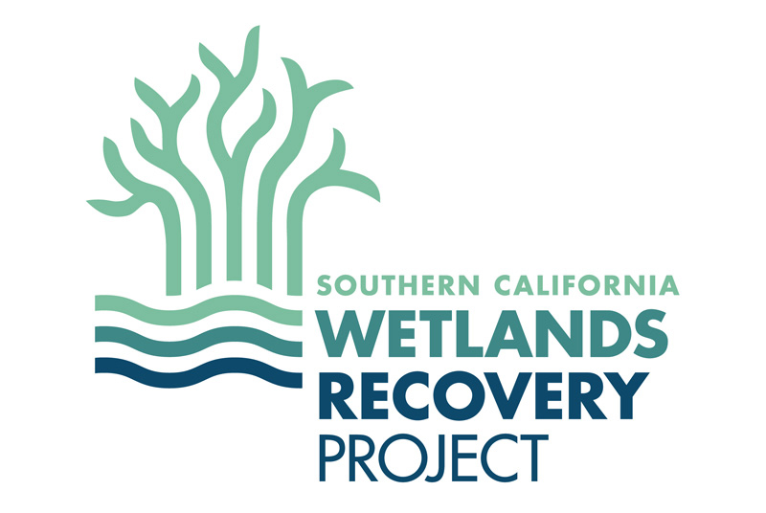
SOUTHERN CALIFORNIA WETLANDS RECOVERY PROJECT (WRP)
WORK PLAN PROPOSAL
2024

APPLICATION INSTRUCTIONS FOR GOAL 1 (TIDAL WETLANDS)

PROPOSAL FORMAT AND APPLICATION INSTRUCTIONS
The Southern California Wetlands Recovery Project (WRP) is soliciting applications for projects that restore and preserve coastal wetlands to be added to their Work Plan under Goal 1. More information about the WRP and Goal 1 Objectives can be found in the Regional Strategy 2018.

Benefits to being added to the WRP Work Plan include:
- Receiving input from WRP member agencies, including multiple state and federal funding and regulatory agencies, on project design, impacts, tasks, budgets, etc.
- Permit pre-application coordination meetings where permitting agencies offer meaningful insight and assistance prior to the permit application process.
- May result in a project being more competitive for agency funding.
- Technical assistance in identifying relevant grant opportunities and coordination with the appropriate agency.

Each complete application should include the following:
- Proposal Summary and Narrative (use application template below)
- A regional map indicating the project area/site map (attached as a separate file).
- 1-3 labelled photos of the project site condition (attached as separate files). Photos should aid the reviewer in understanding key conditions of the site and should be well-labelled. Do not embed pictures into the project proposal; project photos and a map should be attached as separate files.
*Please do not include unsolicited documents such as resumes or letters of support; these will be requested if needed.

Be sure to cite specific information about how your project addresses Goal 1 Objectives of the Regional Strategy 2018. Also, address how your project relates to the WRP’s Guiding Principles (Regional Strategy 2018, page 10).

Complete application package should be named “Goal 1 Application_Project Name_Date” and emailed to Katie Nichols at Katie.Nichols@scc.ca.gov by COB June 14th, 2024.

PROPOSAL SUMMARY

- Project Name:
- Project Summary (350-character limit-- specify key action(s) to be undertaken):
- Project Start Date:
- Estimated Project End Date:
- Location:
  - County:
  - Watershed:
  - WRP Subregion: (see Figure 4 from Regional Strategy 2018)
  - State Senate District (#):
  - State Assembly District (#):
  - U.S. Congressional District (#):
  - Latitude: (Decimal degrees)
  - Longitude: (Decimal degrees)
- Contact Information:
  - Name:
  - Title:
  - Organization:
  - Address:
  - Telephone:
  - Email:
  - Website (if available):
- Project Maps & Photos (sent as an additional file(s).
  - A regional map indicating the project area
  - A map of the project site
  - 1-3 labelled photos of the project site condition
- Acreage:
For questions on acreage and habitat type* please answer them to the best of your ability. If acreage for a specific category below is unknown at this time, you can say so. You can reference historical and current tidal wetlands maps here:
https://databasin.org/galleries/298604627cac4283a8a970866ab605bc/
https://databasin.org/galleries/34014c4046874d8a8e4ef2b55334c1ce/

If you do not know the acreage of your project area, you may use Google Earth to estimate the acres. Click the ruler tool and outline the bounds of your project. The acreage will show up on the right-hand side of the screen.

  - Total acreage of project footprint:
  - Total acreage of area affected by project¹:
  - Acres of existing (pre-project) wetland habitat (vegetated marsh, unvegetated flats, subtidal):
  - For Planning & Restoration Projects (NA for Acquisition): Estimated acres of post-project wetland habitat (vegetated marsh, unvegetated flats, subtidal):
  - Acres of post-project transition zone habitat:
  - Feet of stream corridor (if applicable):
- Project Type & Phase (select all that apply):
☐ Acquisition:
☐ Acquisition (involves the purchase of property or a conservation easement)
☐ Restoration Planning:
☐ Feasibility Study
☐ Conceptual design (typically 0-30% design)
☐ Preliminary design (typically 30-60% of design and can include permitting and CEQA/NEPA)
☐ Final Design (typically 60-100% of the design and can include permitting and CEQA/NEPA)
☐ Restoration Implementation:
☐ Implementation (typically includes construction, but may also include other activities such as demolition, planting and weed control, conducting environmental education programs, etc.)
☐ Monitoring & Evaluation (monitoring associated with evaluating project success)
☐ Operation & Maintenance (activities need to enable a project to continue providing the intended benefits.
☐ Interpretive/Education
☐ Science and Monitoring
- Primary Habitat Type^{2:}
☐Tidal Wetland (Estuarine Wetland)
☐ Aquatic Bed
☐ Emergent Saline to Brackish Marsh
☐ Forested
☐ Marsh
☐ Mudflat
☐ Non-vegetated
☐ Sub-merged aquatic vegetation
☐ Tidal Wetland (Other)
(Specify here)

☐ Riparian
☐ Rivers and Streams (includes fish passage)
☐ Transition Zone (buffers & upland)
☐ Subtidal
- Goal 1 Regional Strategy Objectives (summarized on pgs. 31-32 of RSU):
If known, address how your project does or does not meet the following RSU goals:
  - 1B. Total number of wetland acres sustained after 24” of SLR
    - Total number of unvegetated acres:
    - Total number of vegetated acres:
  - 5A. Protect existing transition zones up to 1,600’ from wetland
    - Percentage of the wetland perimeter that has transition zone:
    - Average width of the transition zone:
  - 5D. Adjacent habitat for upstream migration of wetlands after 24” of SLR
☐ Yes (Select Yes if the system has a river or creek that allows for upstream migration of wetlands, at least to the tidal limit under 24 inches (0.6m) of SLR)
☐ No (Select No if it does not)
☐ N/A (Select NA if there is no river or creek associated within the project area)
- Date Permit(s) Obtained or Expected Date for Submission:
- Expected CEQA Completion Date:
- Budget Summary:
  - Total project cost: $ _
  - Funding secured to date: $ _
  - Funding requests under review: $ _____________
  - Funding Gap: $ _____________

PROPOSAL NARRATIVE

Please use the following outline as a guide in preparing the project narrative for your Goal 1 application. To help you determine the level of detail desired, recommended lengths for each section are indicated in parentheses.

1. Site Description (1-3 paragraphs)
- Describe the project area.
- Describe current site ownership and management.
- Describe past and present uses of the site.
- Describe historical habitats found at the site.
- Identify the primary vegetation communities found at the project site within the following habitat types (if present): wetland-upland transition zone, vegetated marsh, unvegetated flat, subtidal habitats, and non-tidal wetlands.
- Identify stressors such as invasive species.
- Identify any federally or state-listed species (endangered, threatened, species of special concern) known to use or potentially use the site.
- For acquisitions: Identify the property owner(s). Property owner must be a willing seller. Describe property owner’s support of the project. Specify if an appraisal for the property has been completed. List intended uses of the property after acquisition, including conservation easement or other method for restricting use.

2. Project Description (1 page)
- Need:
  - Describe the need for the project. Be concise and specific.
- Goals and Objectives:
  - Outline the specific environmental goals for the project, including measures of success.
  - Describe how the project will help achieve the Goals and Objectives of the Regional Strategy 2018.
  - See the WRP Guiding Principles on page 10 of the Regional Strategy 2018 for additional project selection criteria. Be sure that the project has addressed these Guiding Principles.
- Tasks:
  - Define the project acreage and stream miles for the project footprint and area affected. The Area Affected will be the same or larger than the Project Footprint, for example, projects that remove barriers to tidal flow in a lagoon may have a small project footprint but affect the entire lagoon.
  - Summarize the specific action(s) and tasks to be undertaken and reference the Task table to be filled in below. Tasks include acquisition, restoration, education, and outreach components of the project. Potential tasks are listed under #9, above.
  - How do your actions preserve or restore physical and ecological processes?

Table 1. Use the table to describe the major project elements or tasks to be completed. Add rows if needed.

Task # | Task Name | Description | Start  Date | Completion Date
1
2
3
4
5

3. Project History and Development (1-2 paragraphs)
- What alternatives were considered and why was the proposed project selected? What ecological trade-offs were considered?
- How were climate change impacts, and sea-level rise in particular, considered in the project design?
- Has this project been specifically identified in a previous planning document?
- Explain the status of CEQA review for the project. Has CEQA review been completed? If not, be sure to include completion of CEQA in project tasks and budget.
- Describe the permitting status of the project.
- Describe the timing or urgency of the project.

4. Coordination and Partners (1 paragraph)
- Describe on-going and anticipated coordination and partnership with affected public agencies, non-profit organizations, elected officials, tribal governments, or private entities, landowners, and other interested parties.
- Describe involvement in the development of the project by communities impacted or benefited by the project – i.e., is there an anticipated community outreach process. Have tribes been consulted, or have tribes expressed interest in the project?

5. Long-term Management (1 paragraph)
A project site may need to be operated, used, and maintained for the project life (up to 25 years), depending on the funding agency and funding source.
- Explain how the proposed restoration/enhancement will be maintained, including how the project was designed to account long-term management needs and how activities will be funded.
- How many years will the project be maintained post-project completion?

6. Monitoring (1 paragraph)
- Describe the monitoring program for the project. Include monitoring metrics, success criteria, reference conditions, monitoring frequency, and reporting plan. If project achieves a specific objective of the Regional Strategy 2018, make sure to include all of the tracking measures listed in the report for that objective.
- Describe how adaptive management will be used to address issues that arise.

7. Applicant’s Applicable Experience (1 paragraph)
- Describe the applicant’s previous experience that demonstrates ability to complete the project successfully.
- Describe similar projects that have been successfully completed by the applicant and subcontractors (if any) or any other applicable experience that indicates capability to implement the proposed project.

8. Budget Information
- For the tasks outlined in Table 1 above, provide the total estimated cost for each task, the funding gap, and any funds already secured along with the funding source in Table 2, below.
- If desired, provide a brief justification below the table for how the costs were calculated.

Table 2. Use the table to provide budgets for the major project elements or tasks to be completed. Add rows and columns if needed.

Task # | Task Name | Total Cost | Funding Gap | Funds Secured and Source
1 |  | $ 0 | $ 0 | $ 0
2 |  | $ 0 | $ 0 | $ 0
3 |  | $ 0 | $ 0 | $ 0
4 |  | $ 0 | $ 0 | $ 0
5 |  | $ 0 | $ 0 | $ 0
GRAND TOTAL |  | $ 0 | $ 0 | $ 0

See Project Description section below.
Answer acreage and habitat type questions to the best of your ability or state as unknown.
Transition zones are areas that allow for future wetland migration and have no structures impeding migration.

