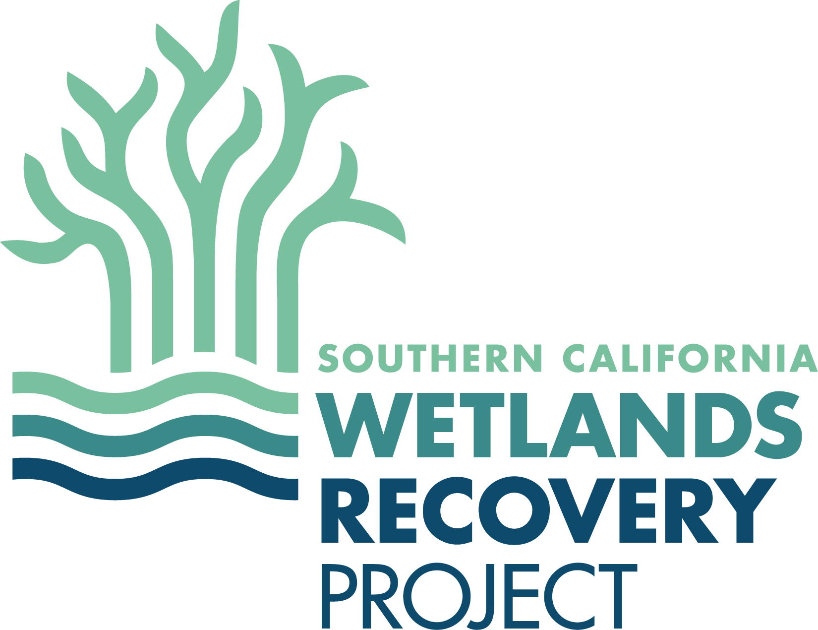

SOUTHERN CALIFORNIA WETLANDS RECOVERY PROJECT
Director’s Group Meeting
DRAFT AGENDA
February 27, 2020
10:00 a.m. – 3:30 p.m.

10:00 SITE VISIT TO LOS CERRITOS WETLAND RESTORATION PROJECT
Joel Gerwein, State Coastal Conservancy

11:30 LUNCH ON YOUR OWN
Marketplace Long Beach across from Site Visit location
Plan for 30-minute transit to meeting

1:00 INTRODUCTIONS and ANNOUNCEMENTS, AGENDA PREVIEW
Mark Gold, Chair
Executive Director, Ocean Protection Council & Deputy Secretary for Ocean and Coastal Policy, Natural Resource Agency

Recommended Actions:
Approve Meeting Minutes from October 18, 2018

1:15 WORK PLAN 2020
Evyan Sloane, State Coastal Conservancy

Recommended Action:
Approve Work Plan 2020

1:45 MAJOR PROJECT ISSUES
Megan Cooper, State Coastal Conservancy

Discuss major issues facing large-scale coastal wetland restoration projects.

2:15 REGIONAL COORDINATED PERMITTING
Melissa Scianni, Chair WRP Wetland Managers Group

Discuss options to lessen approval times for Work Plan projects.

Recommended Action:
Produce Sand in the Gears report

2:45 FUNDING WETLANDS RESILIENCE PROJECTS
Sam Schuchat, State Coastal Conservancy

Discuss potential funding for Work Plan projects.

3:00 IN-LIEU FEE PROGRAM UPDATE
Evyan Sloane, State Coastal Conservancy

Discuss status of WRP in-lieu fee program.

3:15 PUBLIC COMMENT (Each speaker is limited to 3 minutes.)

3:30 ADJOURN

