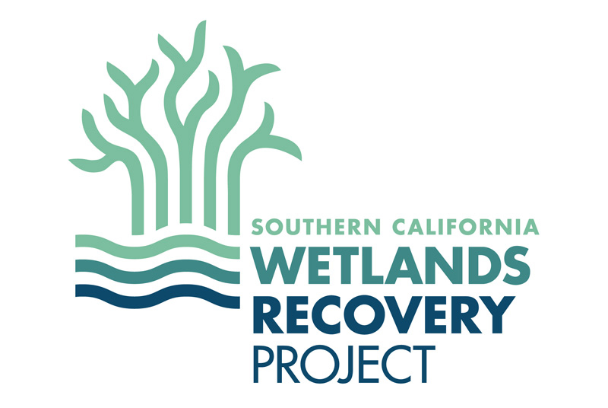

2019-2020 State Coastal Conservancy Community Wetland Restoration Grant Program

PROGRAM INFORMATION AND APPLICATION GUIDELINES

BACKGROUND
The State Coastal Conservancy Community Wetland Restoration Grant Program (CWRGP) provides funding for community-based restoration projects in coastal wetlands and along coastal stream corridors in the southern California region. The goals of the program are to build local capacity to plan and implement wetland restoration projects; promote community involvement in wetland restoration activities; and foster education about wetland ecosystems. These goals are consistent with the Southern California Wetlands Recovery Project (WRP) Regional Strategy, entitled the Regional Strategy 2018. A partial compilation of projects funded in past CWRGP cycles can be found on the WRP website Project Board. The Wildlife Conservation Board and the Earth Island Institute will assist the Conservancy with the CWRGP 2019-2020 grant round.

PROGRAM DETAILS
Eligible Applicants: Eligible applicants include 501(c)(3) nonprofit organizations, local government agencies (City or County), and university departments. Proposals from local government agencies and universities that partner with local nonprofit organizations on their proposed project will be looked upon more favorably than those that do not.
Eligible Projects: To be eligible for funding, projects must restore wetland habitat and involve community in the restoration implementation; more specifically:
- Restoration or preservation of a coastal wetland or coastal stream corridor: Projects must have as a primary goal the restoration of a coastal wetland (estuarine or vernal pool) or a coastal stream corridor on public land in southern California from Point Conception to the Mexican border region, including watersheds in Mexico that drain to the Tijuana River.

- Community involvement and educational component: Project implementation must involve community members and have an educational component. Through the CWRGP, the Conservancy is attempting to make significant impacts to both the region’s wetland resources and the region’s communities, with projects that engage and educate the community through their hands-on participation in restoration, resulting in measurable restoration outcomes. This education linked to a restoration experience provides numerous positive feedbacks to the community, such as creating a sense of place, fostering stewardship of wetland habitats, and improving environmental awareness. The CWRGP is particularly interested in engaging a diverse array of community members in the participating projects.

Community Wetland Restoration Grant Program Funding Total: approximately $160,000 for FY 2019-2020
Individual Grant Size: Grant awards may range from $20,000 to $30,000.

Project Selection: A selection committee that includes an Earth Island Institute staff member, a California Coastal Conservancy staff member, and a Wildlife Conservation Board staff member will review the Community Wetland Restoration Grant Program applications and select the projects to be added to the Program. Other agencies that coordinate through the Wetland Recovery Project and that could potentially consider funding CWRGP projects will be invited to participate in the selection committee as well. See “Grant Process” below for additional details.

Selection Criteria: Applications will be evaluated based on the following criteria:
- Extent to which the project will advance hands-on community involvement in a wetland restoration project, particularly involvement beyond the traditional environmental constituency.

- Degree to which the project will help build the applicant’s capacity to plan and implement wetlands restoration projects.

- Extent to which the project will foster education about wetland ecosystems and the impacts and threats to those ecosystems, as well as the opportunities for restoration and the application of Best Management Practices (BMP’s).

- Extent to which the project contributes matching funds or services. There is no required match for Community Wetland Restoration Grant Program funds; matching funds and services, however, can help demonstrate broader community interest and support for the project.

Other Considerations for Applying:
- Proposals should represent projects that are ready to implement. Note that the Community Wetland Restoration Grant Program is designed for relatively low-dollar projects or a distinct portion of a larger project that can be implemented quickly and effectively to achieve on-the-ground restoration while building a community’s capacity for future, potentially larger projects and expanding education and outreach efforts on wetland restoration. A project should have clearly defined goals and outcomes that can be achieved on the order of a year, rather than a project that is encumbered by the increased logistics, such as complex management, permitting, and planning, of a larger multi-year project.
- Do not submit a vague proposal that merely states goals without a specific strategy and planned actions and a timeline to achieve those goals. Be specific.
- The Conservancy will award no more than one CWRGP grant per applicant; therefore, if you have multiple project concepts, pick the highest priority and dedicate the appropriate resources to making that project a successful proposal.
- Follow-on funding (funding over two consecutive grant cycles) to a project is possible but not likely since this would no longer constitute a small grant. Applicants should not expect to be awarded a second CWRGP grant without unique extenuating circumstances.
- CWRGP grants will not be awarded for experiments or research.
- General funding to an ongoing program will not be granted. Startup costs (capital costs) or a specific restoration project within a multiyear program may be considered.
- Funding to an ongoing monitoring project will not be granted. Startup costs (capital costs) for a monitoring project or monitoring tied to a specific restoration project may be considered.
- Projects proposed for upland areas must demonstrate in their proposal a clear connection and benefit to the adjacent wetland habitat.
- In their application, projects should identify a Local Coastal Plan (LCP) or any other relevant plans that support the project. Please list the LCP or other plan(s) name, date, and highlight the specific reference to the project site. Provide a link to the plan if it is available online or provide a hard copy with your proposal submission if the plan(s) is/are not available digitally.
- If the applicant is not the landowner of the project site, the application must include a signed Provisional Landowner Access Agreement (sample attached to Proposal template form) demonstrating the landowner’s willingness to allow the project and acknowledging the requirement to enter into a longer term agreement if the project is funded..
- Grant recipients will be required to enter into fifteen year-long grant agreements with the Conservancy that will impose obligations on the grantee. These are likely to include obligations to: obtain liability insurance, keep certain records, provide a drug-fee workplace, acknowledge Conservancy funding, and operate and maintain the project for fifteen years. Grant recipients that do not own the project site will be required to obtain landowner agreements allowing for the project maintenance (or agreeing to assume the project maintenance) for fifteen years.

Notification: Provisional notification of the grant award or denial will be made in March with formal/final notification occurring after the State Coastal Conservancy Board meeting in May.

APPLICATION GUIDELINES
An electronic copy of the application template is available on the WRP website at scwrp.org; please follow the application template when preparing your proposal. Each application should include:
- Application Summary – one page maximum

- Project Narrative (4 page maximum; no less than 10 pt. font, 1 inch margins) that includes the following sections:
- Site Description.
- Project Description – include the need for the project and specific project tasks to be completed. This section should be the substantial part of the application.
- Permitting/CEQA status
- Ecological benefits of project.
- Description of community involvement and the education elements of project.
- Brief summary of applicant’s experience undertaking wetlands restoration projects.

- Budget. Budget numbers should be rounded to the nearest $100. Please note that the grant cannot be used to pay for food or drink, even for volunteers. No more than 15% of a Coastal Conservancy grant can be used for indirect costs.

- Addendums
a. A regional map (county-scale is appropriate) that clearly identifies the project area; and
a site-scale map that shows the location of project elements.
- One to three photos of the site may be included if they facilitate understanding key site conditions.
- Do not include unsolicited attachments such as resumes, letters of support, etc. These will be specifically requested if they are needed.

APPLICATION PROCEDURES
- Application must be postmarked by February 15, 2019; electronic copies must be received via the Apply button at http://scwrp.org/grants/cwrgp/ by February 15 at 5pm.

- One hard copy should be sent to: Shawn Kelly
Earth Island Institute
1237 Brunswick Lane
Ventura, CA 93001

Please follow the following guidelines for electronically submitting proposals through the website: proposal summary, narrative, budget, and attachments should be uploaded as one file in Microsoft Word or converted to a pdf file if possible. Name the electronic file by the project name. Do not embed pictures in the proposal text; place them in the file after the proposal narrative and have them well labelled. To ensure that your electronic file is not excessively large, make sure your photos are an appropriate size. If possible, please include in your electronic submission images of all maps that are included in the mailed proposal.
Please keep in mind that the Grant Program may receive dozens of applications, both via mail and electronic submission, and those applications that do not follow directions or are poorly organized in content or submittal are not appreciated. Late applications are not accepted. Thank you for your interest and we look forward to working with you.

GRANT PROCESS
- Applications are due February 15, 2019.
- A committee will review applications at a meeting in March and select the projects that will be recommended to the Conservancy for a grant at a public meeting. Applicants will be notified of whether their project will be recommended for a grant. Approval of recommended grants will be considered at the State Coastal Conservancy meeting in May. Notification of grant approval will occur immediately following the Conservancy meeting. Should other funding agencies engage in application review and identify select projects for recommendation under other funding sources, those determinations will be communicated to affected applicants at the time of those agencies’ decision-making.
- Applicants may be asked to provide clarification on their proposed project or additional information about their project regarding CEQA review and consistency with local coastal planning.
- The State Coastal Conservancy will enter into grant agreements with successful applicants during June - August 2019.
- Funding for all projects receiving Conservancy funding will be available not later than September 2019. CWRGP is a reimbursable grant program, meaning funds are payable in arrears, not in advance.

INQUIRIES should be directed to:
Shawn Kelly, Earth Island Institute
(805) 628-9459; skelly@earthisland.org

This number may be increased depending on response and budgetary considerations.

