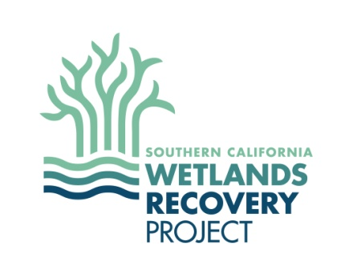
Wetland Advisory Group (WAG) Meeting #2
September 15 & 22, 2015
10:00am to 2:00pm

Meeting Goals:
- Present Regional Strategy Update (RSU) draft products and solicit WAG feedback

Agenda:
10:00 WAG Update and Overview of Meeting Goals
Shawn Kelly, Wetlands Recovery Project

10:30 Presentation: Science Advisory Panel (SAP) Progress on Approach for RSU
Jeremy Lowe, San Francisco Estuary Institute

11:00 Discussion: SAP Progress on Approach for RSU
Facilitated by: Jocelyn Christie, CA Sea Grant Fellow, Coastal Conservancy

12:00 Lunch

12:30 Overview & Discussion: SLR Decision Support Tool
Facilitated by:
Evyan Borgnis, Coastal Conservancy & Danielle Boudreau, NOAA Coastal Training Program

2:00 Adjourn

