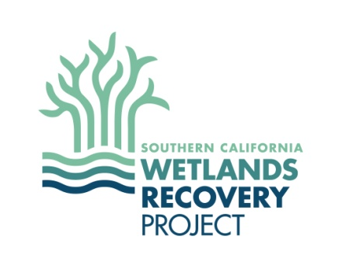

Wetland Advisory Group (WAG) Meeting
Monday June 22, 10:00am to 2:00pm

Meeting Goals:

Agreement on purpose of WAG

Understanding of purpose of Regional Strategy Update
- Provide feedback on Climate Change Management Questions

Agreement on Guiding Principles and Fundamental Goals

Agenda:

10:00 Meeting Goals and Purpose, Introduce the WAG

Jocelyn Christie, CA Sea Grant Fellow, Coastal Conservancy

OBJECTIVE: Agreement on purpose of WAG

10:20 Regional Strategy Update Overview

Greg Gauthier, Coastal Conservancy

OBJECTIVE: Understanding of purpose of Regional Strategy Update

10:45 Science Advisory Panel (SAP) - Progress and Products

Christine Whitcraft, SAP Chair, Cal State Long Beach

11:00 WAG Discussion on SAP Products - Climate Change Management Questions

Christine Whitcraft, SAP Chair, Cal State Long Beach
OBJECTIVE: Provide feedback on Climate Change Management Questions

11:55 Lunch

12:25 Wetland Managers Group (WMG) Introduction

Carolyn Lieberman, WMG Chair, U.S. Fish and Wildlife Service

12:35 WAG Discussion on WMG Products - Guiding Principles and Foundational Goals

Greg Gauthier, Coastal Conservancy
OBJECTIVE: Agreement on Guiding Principles and Foundational Goals

1:45 Next Steps and Wrap-up

Jocelyn Christie, CA Sea Grant Fellow, Coastal Conservancy

2:00 Adjourn

